To remove these buttons from input type number

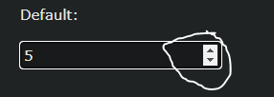

Do this in the CSS file

/\* Chrome, Safari, Edge, Opera \*/  
input::-webkit-outer-spin-button,  
input::-webkit-inner-spin-button {  
  -webkit-appearance: none;  
  margin: 0;  
}  
  
/\* Firefox \*/  
input[type=number] {  
  -moz-appearance: textfield;  
}